English for Mechanical Enginneers 4

Bartlomiej Wroblewski, M.A.

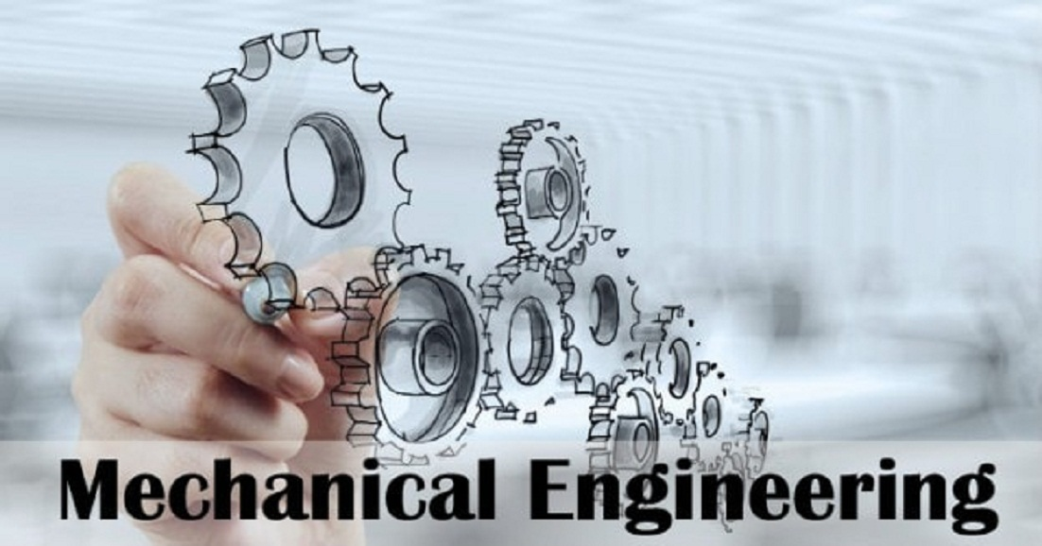
AST4 Lesson 1

Lesson 1 - Safety at Work

- Label the safety equipment in the pictures below.

hard hat = safety helmet / googles / breathing mask / gloves / ear protectors / overall / apron / reflective vest / welding mask / safety boots = protective footwear / ear plugs
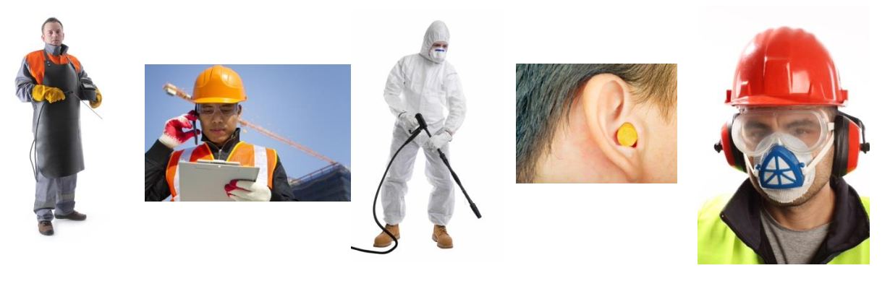

- Complete the sentences. Use the correct form of the modals and the passive or active form of the verbs in brackets.

- Welders ____________________ (must / wear) protective aprons.
- This package ____________________ (should / send) as soon as possible.
- Gas cylinders ____________________ (must not / drop).
- Watch your step. You ____________________ (could / trip) over stones.
- Ear protectors ____________________ (must / wear) here.


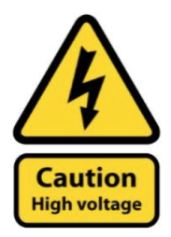
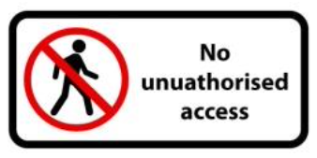
- Can you make safety rules for the following safety notices? Write full sentences with the passive voice.
e)
d)
c)
b)


a)

- _______________________________________________________________________.
- _______________________________________________________________________.
- _______________________________________________________________________.
- _______________________________________________________________________.
- _______________________________________________________________________.
- Listen to the recording, and then answer the questions. Decide whether the statements are true or false, fill in the gaps and answer the questions. (AST4 12.1)

- Safety rules are important even in your home workshop. T x F
- Every item in your workshop should have its place. T x F
- Inflammable materials must be used during welding. T x F
Remember to wear safety (4) _________________ and a face shield when grinding or using cutting tools. You (5) ________________ take off this safety equipment because it can (6) _____________ serious injury. Wearing it ensures you will never (7) ________________ go to the emergency room.
- What is necessary to have for all your equipment? ________________________________
- Who are dangerous visitors to your workshop? __________________________________
- What should always be prohibited in your workshop? _____________________________

- Write a few rules (active and passive) you need to follow when:

driving a forklift truck
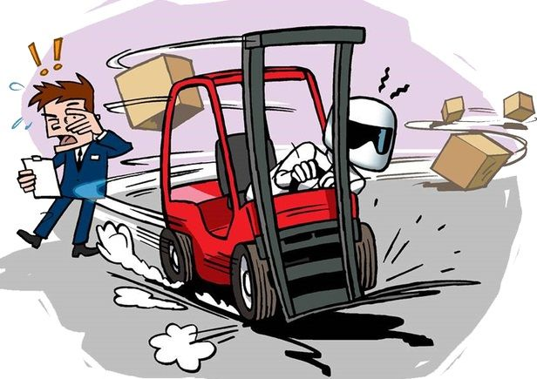

________________________________________________________________________________
________________________________________________________________________________
________________________________________________________________________________
________________________________________________________________________________
________________________________________________________________________________
________________________________________________________________________________
________________________________________________________________________________
________________________________________________________________________________
________________________________________________________________________________
________________________________________________________________________________
________________________________________________________________________________
________________________________________________________________________________
________________________________________________________________________________ ________________________________________________________________________________
________________________________________________________________________________
AST4 Lesson 2

Lesson 2 - Accident Report
- Discuss these questions with your partner:

- How can people improve their workplace safety?
- Do people in the CR care about safety in the workplace? Why? Why not?
- What is the difference between an accident and an incident?

- Brainstorming. What can cause these things in a workplace?

- slip
- trip
- fracture
- fatigue = tiredness
- cut
- backache

Useful adjectives: untidy / disorganised / improper / uncomfortable / inadequate / unsafe / inattentive

- Fill in the blanks with the following three phrases: caused by / result from / result in. Change the verb form if necessary.

- Improper training can ___________________ many injuries.
- Repetitive Strain Injury (RSI) often ___________________ improper wrist or elbow support.
- Incidents are ___________________ inattention.
- Slips and trips ___________________ unsafe working conditions.
- Badly chosen chairs can ___________________ severe backache.

- What is the difference between the phrases listed in ex. 3?

________________________________________________________________________________ ________________________________________________________________________________ ________________________________________________________________________________ ________________________________________________________________________________

- Listen to the recording and make notes. Explain what happened. (AST6 3.1)

________________________________________________________________________________ ________________________________________________________________________________ ________________________________________________________________________________ ________________________________________________________________________________

When we describe an accident/incident, we use past tenses:

Martin Smith fell down the stairs and hurt his head. — Past Simple (active)
He was taken to hospital. — Past Simple (Passive)
He wasn’t wearing gloves when he was operating the machine. — Past Continuous

- A description of an accident. Fill in the gaps with proper past tenses.

Martin Wood _______________ (cut) his finger when he _______________ (operate) a lathe. He _______________ (turn) the lathe on leaving the guard open. When the accident _______________ (happen), he ______________ (talk) to his friend. John Watson ______________ (see) the accident and _______________ (give) first aid right away. After that he _______________ (call) emergency. Martin Wood _______________ (take) to hospital where he _______________ (treat).

- Now look at the questions the health and safety officer asked when interviewing the witness. Put the words in the correct order and write the questions.

- happened / what? _____________________________________________________________________
- accident / did / the / when / happen? _____________________________________________________________________
- in / was / accident / involved / who / the? _____________________________________________________________________
- follow / he / the / did / operating / standard / procedure? _____________________________________________________________________
- get / how / injured / did / the / worker? _____________________________________________________________________
- give / first / anybody / aid / at / did / the / site? _____________________________________________________________________
- accident / other / were / people / who / there / saw / any / the? _____________________________________________________________________

- Work in pairs. Use the questions from exercise 7 and act out an accident investigation interview. Make notes. Student A will use the information from file 1. Student B will use the information from file 2.

________________________________________________________________________________ ________________________________________________________________________________ ________________________________________________________________________________ ________________________________________________________________________________ ________________________________________________________________________________ ________________________________________________________________________________

- Use your notes to write a report. Complete the form below and write 60-80 words. Use past tenses. You may have to invent some details.

Useful verbs: carry, trip, explode, cut, drive, knock, spill, slip, fall, repair, catch (fire), wear, get caught (in machinery), etc.

Employee Accident Report
Date _____________

Employee Manager
Name _____________________ Name ______________________
Title/position _____________________ Title/position ________________

Incident
Date ___________________
Time ___________________
Location ___________________

Description of accident
________________________________________________________________________________ ________________________________________________________________________________
________________________________________________________________________________ ________________________________________________________________________________ ________________________________________________________________________________ ________________________________________________________________________________

File 1
This role play has two stages.
1. You are an accident witness. Answer all questions asked by the health and safety officer. Use the information below:
- burnt his/her arm
- exposed to fire
- at noon
- taken to hospital
2. You are a health and safety officer. Interview the witness. Make notes.

File 2
This role play has two stages.
1. You are a health and safety officer. Interview the witness. Make notes.
2. You are an accident witness. Answer all questions asked by the health and safety officer. Use the information below:
- slipped on
- broke her/his leg
- 14:00
- taken to hospital

AST4 Lesson 3

Lesson 3 - Problems and Solutions

Warmer
What has broken down in your house or flat recently? What have you done with it?
Have you fixed it yourself or has anyone advised you?

- Look at the possible defects and think about things which might have these problems.
jammed, blocked, flat, corroded/rusty/rusted, loose, empty, blunt, too tight, broken, chipped, scratched, dented, leaking/leaky, cracked, torn, worn out
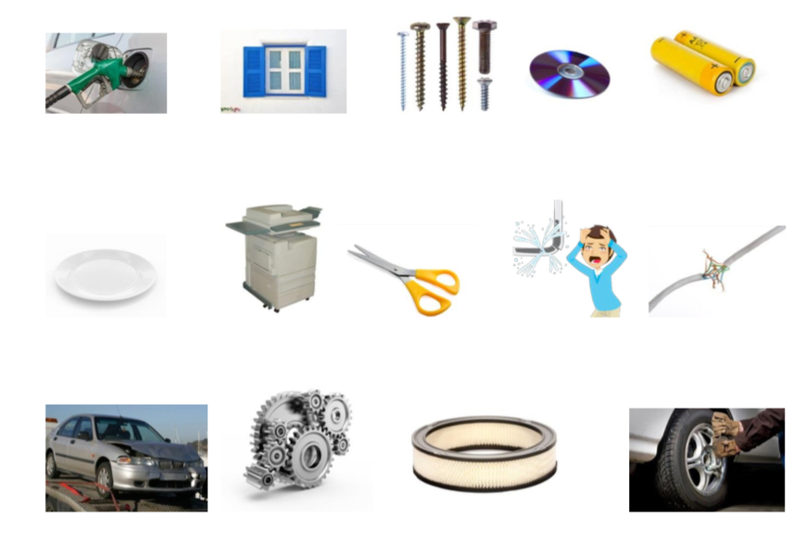
You will listen to three short dialogues. The people in each dialogue try to solve a technical problem. Listen and note down the things and problems the people discuss in each dialogue and what possible explanation they offer. (AST4 track 1)

a) Problem: _________________________________________________________________ Solution: ___________________________________________________________________ b) Problem: _________________________________________________________________ Solution: ___________________________________________________________________ c) Problem: _________________________________________________________________ Solution: ___________________________________________________________________

- Your friend tells you about his/her problems. Suggest possible solutions using the phrases from the table below.
Suggesting a solution:

- Try + verb + ing …
e.g. Try clicking on the "undo" button.
- Why don’t you + infinitive …?
e.g. Why don’t you click on the "undo" button?
- How about + verb + ing …?
e.g. How about clicking on the "undo" button?
- You could + infinitive …
e.g. You could click on the "undo" button.

a) The plate is chipped. ________________________________________________________________________________
b) The scissors aren’t cutting properly.
________________________________________________________________________________
c) The lamp isn’t working.
________________________________________________________________________________
d) The door key isn’t working.
________________________________________________________________________________
e) The computer isn’t working.
________________________________________________________________________________
f) The torch has stopped working.
________________________________________________________________________________

AST4 Lesson 4

Lesson 4 - Materials

- With your partner, make a list of as many materials as you know. You have one minute for this.
________________________________________________________________________________
________________________________________________________________________________
________________________________________________________________________________

- Look at the following names of materials. Can you get the correct word from the letters?
lodg | nit | micrace
slsag | boradcdar | gfilassbre
eppar | ttonoc | wdylpoo
ynoln | dlea | inor
srabs | bberru | lypotnehe
reigtpha | leest | lumianumi
ethealr | oolw | kvlrea

- Which of the materials from ex. 2 are natural? Which of them are artificial?
________________________________________________________________________________
________________________________________________________________________________
________________________________________________________________________________ ________________________________________________________________________________

- Work in pairs. Together with your partner, come up with the names of two objects that can be made of:
- porcelain ____________________________
- fibreglass ____________________________
- steel ____________________________
- silk _________________________________
- ceramic ______________________________
- polyester _____________________________

- Are the following sentences true or false? If they are false, correct them.
- Elements that make up a compound are chemically bound.
- Copper is a non-ferrous alloy.
- Alloys are chemical compounds that are frequently used in engineering.
- Alloys can contain both metallic and non-metallic elements.
- Bronze is a metallic element.

- Discuss in pairs. What’s the difference between "to be made of" and "to be made from"?
- The table is made of wood.
- Paper is made from wood.
________________________________________________________________________________
________________________________________________________________________________
________________________________________________________________________________

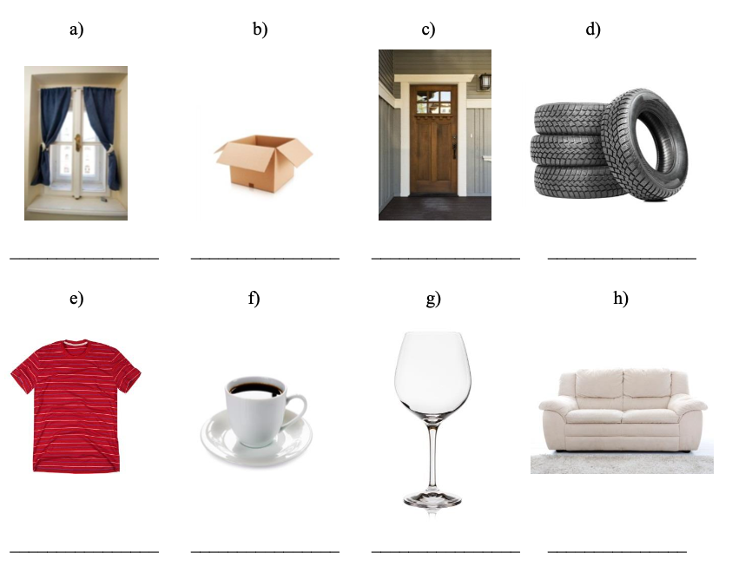
- Look at the following pictures of objects. What materials are they made of?
- Listen to a short excerpt about the materials used for cars in the 1950s. Listen carefully and complete the table below.
Type of material | Used for…?

- Divide the following words into three groups.
composite, plastic, titanium, oak, oak tree, polymers, polythene, iron ring, glass, copper, rubber, material, timber

A | AN | ——

- When do we use the zero article ( - )? When do we use a/an?
- We use ______ with singular forms of countable nouns.
- We use ______ with uncountable nouns or plural forms of non-specific countable nouns.

AST4 Lesson 5

Lesson 8 - Material Properties

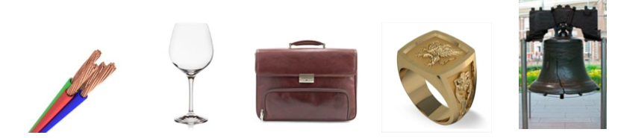
- Look at the pictures below. What materials can be used to make these things? Are they natural or synthetic/artificial?

________________________________________________________________________________________________________________________________________________________________________________________________________________________________________________________________________________________________________________________________
- Work in a group of two or three. Read the following material descriptions and decide which of the materials above they relate to.
___________________This material is an alloy of pig iron and carbon. When subjected to a lot of stress, it can be brittle. It is a great engineering material because of its low melting point, excellent machinability and resistance to heat and wear. The material has a wide range of applications. It can be used in pipes, machines and car parts, such as gearbox cases. We can find this material in our kitchens as well.
___________________Transparency is the most typical property of this material. In addition, it is rather solid, but also brittle. It can break into pieces. It can be formed into various shapes, which is why it is used in many areas of our lives. Additives, such as cobalt or manganese, may change the colour of this material.
___________________This natural material is quite durable and flexible. It is a good heat barrier and provides excellent heat insulation. It is also resistant to fire, tearing or puncturing. It is a material which can be moulded into various shapes and dyed many different colours. Its application ranges from furniture to clothing.
_________________This material, which has been used for thousands of years, is a ductile metal with great thermal and electrical conductivity. It is very soft and malleable. The material is found in many alloys as well, such as bronze and brass. The metal has a very wide range of uses, for example, for kitchenware, sculpture, lighting fixtures and jewellery. It has a very unique colour, too.
___________________This material is also very unique in colour. It is a quite expensive, soft and conductive natural material. It has been typically used for jewellery, but due to its corrosion resistance, its use nowadays includes microelectronics as well.

- Match the material properties with their definitions.
toughness, plasticity, hardness, conductivity, tensile strength, malleability, elasticity, ductility
a) ______________________
The ability of a material to flex in different directions and return to its original position.
b) ______________________
The ability of a material to be changed in shape permanently.
c) ______________________
The ability of a material to deform by stretching along its length (tensile stress).
d) ______________________
The amount of force necessary for a material to break by stretching it.
e) ______________________
It is a substance's ability to deform under pressure (compressive stress).
f) ______________________
It’s a measure of how much deformation a material can undergo before breaking.
g) ______________________
The ability of a material to resist scratching, tearing, indentation, etc.
h) ______________________
The ability of a material to conduct electricity.

- Make adjectives for the following names that describe material properties.
NOUN | ADJECTIVE
plasticity
elasticity
machinability
malleability
flexibility
durability
ductility
transparency
thermal/electrical conductivity
strength
softness
hardness
toughness
brittleness
heat/fire/corrosion/wear/scratch resistance

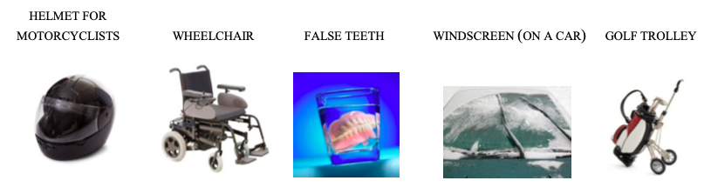
- In a group of three, discuss the following products and decide which materials are the most suitable for their production and why. Then compare your ideas with another group.

- You are going to listen now to a design engineers’ discussion about one of the products mentioned above. Which materials do they agree on and why? (AST4 track 7)

Best material for the frame: ____________________________________________________ Reason: ____________________________________________________________________
Best material for the wheels: ___________________________________________________ Reason: ____________________________________________________________________
Best material for the bag: ______________________________________________________ Reason: ____________________________________________________________________

AST4 Lesson 7

Lesson 7 - Measurements and Units

- Work in pairs. Practise saying the following figures.
- 14,640 s ______________________________________________________________________
- 33.53 km _____________________________________________________________________
- 120 km/h _____________________________________________________________________
- 0.5% ________________________________________________________________________
- 1/3 __________________________________________________________________________
- 2/3 __________________________________________________________________________
- 4/7 __________________________________________________________________________
- Match the following expressions with their definitions.
- digit 6:3=2
- addition 2x3=6
- subtraction 6
- multiplication 5-3=2
- division 2+3=5
- fraction 5/8

- Work in pairs and try to read the expressions from ex. 2.
- 6 : 3 = 2
- 2 x 3 = 6
- 5 - 3 = 2
- 2 + 3 = 5
- 5/8

- Your teacher will give you a list of different figures and mathematical expressions. Dictate them to your partner and check if they have written them down correctly.

AST4 Lesson 9

Lesson 10 - Basic Mechanisms and Motion

- Look at different kinds of motions and decide if the sentences are true (T) or false (F).
- The piston in the cylinder rotates.
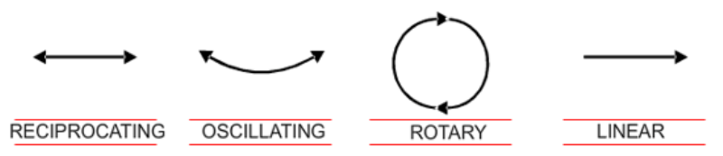
- The pendulum of the wall clock oscillates.
- The train moves in a reciprocating motion.
- The shaft moves in a rotary motion.
- The chain drive transforms linear motion into oscillating motion.

AST4 Lesson 10

Lesson 10 - In a Hotel

- In pairs. Discuss the following questions:
- Would you be happy to travel regularly on business (e.g. every month)?
- What are the five most important things you should take on a business trip?
- What kind of things do you think travel expenses should cover?
- Should a business traveller stay in a five-star hotel or something cheaper?
- Now we have the internet, there is no real reason for business travel. Do you agree? Why?

- Fill in the gaps with the words below. These words are used to describe different types of accommodation.
hotel / camp / tent / pension / under the stars / hostel / hall of residence / motel
- Especially for young people, staying in a _____________________ is nice, because you meet many people.
- During the semester students are usually accommodated in a _____________________.
- When we are on a trip with our car, we can stay in a ___________________ along the way.
- Staying in a _____________________ is usually less expensive and less comfortable than staying in a hotel. But still you can have your own room with a bathroom.
- When you want to sleep outdoors, you often sleep in a _____________________ or only _____________________.
- The _____________________ we were staying in on our holiday had four stars.
- When you are on a canoeing trip, you usually sleep in a _____________________.
- What are the most common room rates when staying in a hotel/hostel/pension, etc. ? Match the words in column A to the descriptions in column B.
A B
- single room the room rate includes breakfast
- double room a room with one bed
- B&B the room rate includes all meals
- half board a room with one large bed or two beds
- full board the room rate includes all meals including drinks
- all inclusive the room rate includes breakfast and one other meal

- Which phrases could be said by a receptionist (R) and which by a guest (G)?
- Do you have any vacancies?
- The dining room is open from … until …
- I’d like a room with a sea view/a balcony/a bath…
- Could you tell me the daily rate?
- How long will you be staying?
- Can you offer me any discount?
- What’s the price per night?
- How many adults and children will be in the room?
- Marriott Hotel, John Brown speaking. How can I help you?
- Does the room have air conditioning/internet access…?
- Is there a swimming pool/a sauna…?
- The daily rate I can give you is £60 with tax.
- I’m afraid I have to cancel our reservation.

- Fill in the missing words.
included / deposit / non-smoking / book / allow / make / change / check-out
- I would like to _______________ a single room.
- I’d like to _______________ a reservation.
- We require a credit card number for a _______________.
- What is the standard _______________ time?
- Is breakfast _______________?
- Do you _______________ pets?
- Would it be possible to _______________ the date of the booking to May 27th?
- Do you want a _______________ room?

- Listen to three people complaining about some of the things above. Then answer the questions.
Dialogue 1:
- What is the problem in the bathroom? _____________________________________________
- Who will come to fix the problem? _____________________________________________
- What does the shower head provide? _____________________________________________
Dialogue 2:
- What kind of English breakfast does the woman want? ________________________________
- Why are there sausages and bacon in the breakfast? __________________________________
Dialogue 3:
- What is the problem described in this phone call? ____________________________________
- What is the man’s room number? _________________________________________________

Additional Materials — Speaking Cards
It is recommended that students use the phrases from exercises 4 and 5.
Student A
You want to book a room at Admiral Hotel.

You want:
- room for 4 people: 2 adults, 2 children (any discounts?)
- sea view
- balcony
- bath not shower
- half board (included in the price?)
- stay in July for 2 weeks

Ask about:
- parking – free?
- swimming pool
- beach chairs
- special activities for children
- price
- how far to the beach, shopping centre
- when can you check in/out
Student B
You’re a receptionist at Admiral Hotel. You can offer student A:
- room from 10th to 24th July (€50 per person per night)
- double bed with two extra beds for children
- 30% discount for children under 10 (ask about the children’s age)
- breakfast included in the price; half board - extra €10 per person per day
- parking included in the price
- no swimming pool
- you have a spa centre for adults and a game room for kids
- no room with a balcony is available
- sea view – extra €5 per person per night
- check-in after 12, check-out before 10

AST4 Lesson 11

Lesson 12 - Attachments


- Go to the website www.wordwall.net/resource/15012385 (You can also use the QR code.) and study the vocabulary that describes attachments.

- Have a look at the sentence describing the picture. When do we use the prepositions "to" and "with" to describe attachments?
I connected my phone TO the screen WITH a cable.
- Fill in the gaps with the missing prepositions.

to (x3) / together (x2) / with (x2) / from (x1)
- The boxes are tied _____ a cord.
- The door is hinged _____ the frame.
- The two devices are connected _____ cables.
- The boards are nailed _____.
- The light is hung _____ the ceiling.
- The metal panel is bolted _____ the floor.
- The gates are chained _____.
- The wires are connected _____ the device.
- Work in pairs. Look at the picture below and describe how things are attached.


- Soldering, welding and brazing are processes that are used to join various materials. Match the processes with the pictures below.
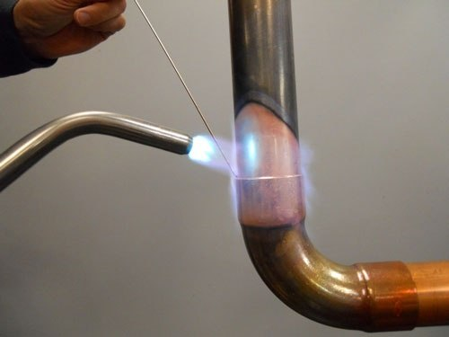
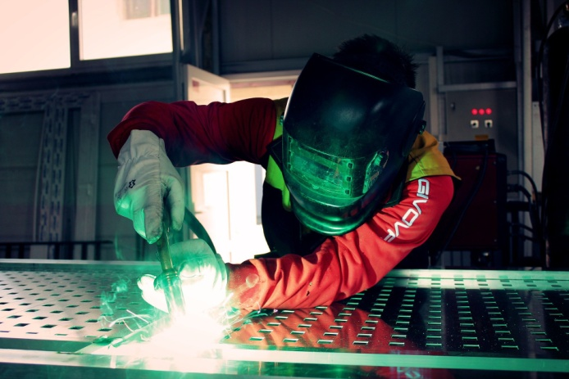
C)
B)
A)
- Listen to a technical specialist explaining the differences between soldering, brazing and welding. Fill in the missing information.
 | soft soldering | brazing = hard soldering | welding
temperature
used tools
process (How are metals joined?)

- Look around the classroom or in your bag and describe how things are attached. Try to describe several things using full sentences. Write at least 80 words.
________________________________________________________________________________
________________________________________________________________________________
________________________________________________________________________________
________________________________________________________________________________
________________________________________________________________________________
________________________________________________________________________________
________________________________________________________________________________
________________________________________________________________________________
________________________________________________________________________________
________________________________________________________________________________
________________________________________________________________________________
________________________________________________________________________________

