English for Mechanical Enginneers 3

Bartlomiej Wroblewski, M.A.



AST3 Unit 1

Unit 1 - Jobs in engineering

- Match the following professions with their descriptions.
- safety engineer
- maintenance technician
- research engineer
- design engineer
- chief engineer
- installation engineer
- welder
- fitter
- machine operator

- I perform metal-joining and metal-cutting processes.
- I analyse hazards and prepare safety documentation.
- I assemble components into larger products and connect equipment to the network.
- I look for new and better ways of designing and manufacturing things.
- I prepare and install products at the customer’s premises.
- I control mechanical equipment.
- I maintain and repair equipment in a factory.
- I transfer ideas into plans.
- I am the highest ranking engineer within a department.

2) Decide what job from the list above would suit you the best and the worst. Explain why.
________________________________________________________________________________________________________________________________________________________________________________________________________________________________________________________________________________________________________________________________

Lesson 1 – A new student in a class

Imagine there is a new student in the class. Read the text about him.
Hello. My name is Pierre Picard. I´m from France and I speak French, Spanish and English. I study at the university of Lyon, my field of study is Mechanical Engineering and my programme focuses on machine design. My favourite subject is Machine Construction because I like making my ideas real. At the moment, I´m improving the design of a hydraulic press.

Prepare a similar paragraph about yourself and write there one thing which is not true.
____________________________________________________________________________________________________________________________________________________________________________________________________________
____________________________________________________________________________________________________________________________________________________________________________________________________________
________________________________________________________________________________________________________________________________________

AST3 Unit 2

Unit 2 - Timetables

- Look at these words. Are they familiar to you? If not, look them up in a dictionary.

- lecture
- lab
- seminar
- lecturer
- attendance

- Discuss these questions with your partner:

- How many hours do you spend at school every week?
- What time do you usually start classes in the morning?
- Which lectures/seminars/labs are your favourite? Why?
- When do you usually have a break?
- Is attendance needed for all your classes?

- Pavel and Hans are discussing their timetables. Listen to their conversation and complete the tasks below.

- Why does Pavel not like his timetable?
- What time does Pavel start on Tuesday?
- When does Hans finish at 8pm?
- Which seminar does Hans have after his French class on Thursdays?
- When can they have lunch together?
- Which lecture are they going to attend together?
- What PE classes do they have? When do they have them?

- Listen again and write the names of their subjects.

- Prepositions of time: IN, AT, ON

ON + days, special days, dates | on Monday, on Tuesday, etc.  on Monday morning  on New Year’s Eve  on Easter Monday  on 15 March  on the 1st of July
AT + periods of time, specific time | at Easter  at Christmas  at 5 pm  at the weekend  at the end of …
IN + months, seasons, years, parts of the day | in June  in summer  in 1838  in the 20th century  in the 1980s  in the afternoon  in the morning (but AT night!!)

- Complete the short text below with the correct prepositions: in, at, on.

The winter semester usually starts ____ September. The first lectures and seminars take place ____ Monday morning ____ 7:30 am. Most students, however, prefer to sleep ____ the morning. Luckily, there are classes ____ the afternoon and ____ the evening as well. The school is only closed ____ night. Students go back home for Christmas ____ the end of December. The campus is completely deserted ____ Christmas. The study period starts____ the first workday after New Year’s Eve. After that, the summer semester starts ____ February.

- What’s the official English name of your university, your faculty and your department? If you’re not sure, find it on the University English website.

My university: ___________________________________________________________________
My faculty: _____________________________________________________________________
My department: _________________________________________________________________

- What subjects can you take at the Faculty of Mechanical Engineering? Match the beginnings (1-7) with the endings (a-g) and find out.

- Manufacturing …
- Machine Components …
- Computer-Aided …
- Materials …
- Metal Forming, …
- Mechanics …
- Fluid …
- Design
- Mechanics
- Casting and Welding
- Processes
- Science
- of Materials
- and Mechanisms

- Suffix "-ics" is often used to form nouns referring to various branches of science. Translate the following branches into English:

- Matematika
- Fyzika
- Mechanika
- Statika
- Kinematika
- Dynamika

- Pair work. Have a look at your timetable and tell your partner when your classes start, when you have free time and what your subjects are. Then note down the details of your partner’s timetable.

 | 7:30 | 8:25 | 9:20 | 10:15 | 11:10 | 12:05 | 13:00 | 13:55 | 14:50 | 15:45 | 16:40 | 17:35 | 18:30
Monday
Tuesday
Wednesday
Thursday
Friday

AST3 Unit 3

Unit 3 - Making phone calls

- Do a little survey among two or three of your classmates: ask questions and complete the chart below.

Ask about: | Name 1: | Name 2: | Name 3:
prefer/making phone calls or sending SMS/why
Q: _________________?
number of phone calls in one day/who to
Q: _________________?
number of text messages in one month/who to
Q: _________________?
person he/she calls/texts most often
Q: _________________?

- You are going to listen to three short telephone conversations. Answer the questions below.

- Where is Natalie? ______________________________________________________________
- Why does Phil leave his phone number? ____________________________________________
- Who does Carl need to talk to? ___________________________________________________
- Who puts Carl through? _________________________________________________________
- Why does the meeting have to be cancelled? ________________________________________
- Where is Pavel now? ___________________________________________________________
- What is Martin doing in Kenya? __________________________________________________

- Which conversation is formal/informal? ____________________________________________

- Now listen again and fill in the gaps in each dialogue.

Conversation A
Woman: Hello?
Phil: Hi, this is Phil Sanders. __________________ Natalie there?
W: I’m ______________________ she’s not here at the moment. She’s got her dancing class. Do you want to __________________a message?
P: Well, yes… ehm… could you tell her to call me back __________________ possible? It’s very important.
W: Sure. Does she have your __________________ ?
P: I think she does... but, just in case, it’s __________________.
W: Sorry, can you _____________ that?
P: Sure. It’s__________________.
W: Right. I’ll give her your message.
P: Thanks. Bye.
W: You’re __________________. Bye.

Conversation B
Samantha: Iron Bridge Ltd, Samantha __________________. How can I help you?
Carl Jung: Hi, this is Carl Jung from Eisen Brücke GmBH. Could I speak to Mr Jason Clark,
__________________?
S: Of course. I’ll __________________ you __________________.
(music)
Clark: Clark speaking.
CJ: Ah, hi Jason. This is Carl. I’m _________________ because of the meeting tomorrow. We must cancel it, I’m afraid. Our marketing manager’s got ill and...
CJ: Sorry, Carl... Could you ___________________ on for a sec? I have someone else on the other ___________________.
C: Sure...

Conversation C
Martin: Hi, Pavel. What’s up, dude?
Pavel: Hey, Martin, I’m in London for two nights. Can we meet?
M: Ahh, that’s a pity. I’m not in the UK right now.
P: Why, where are you? Can you ______________ me?
M: Yeah. I can hear you, but very ______________. I’m on a safari in Kenya. It’s a ____________ signal here.
P: Kenya? OK, right... I’ll better __________________ you then...
M: OK. Anyway, ‘twas nice __________________ to you, buddy, and...
P: Martin, you’re __________________. I’ll talk to you later.
M: OK. Bye.
P: Bye.

- Match the formal phrases with their informal equivalents.

- Hannah Brown speaking.
- Could I speak to Mr Jason Clark, please?
- How can I help you?
- I’m afraid she’s not available.
- Could you please hold?
- May I ask who’s calling?

____ Hang on a sec.
____ It’s Hannah.
____ Who’s this?
____ What’s up?
____ Sorry, she’s busy.
____ Is Jason there?
- Look at the examples in the tables and write the patterns for:

- questions with "do", "does", "did":

 | Does | she | have | your number?
 | Did | you | call | me yesterday?
Who | do | you | need | to talk to?

- questions with "to be":

 | Is | Natalie | there?
Where | are | you | now?

- questions with modal verbs:

 | Can | you | hear | me?
How | can | I | help | you?

- Make questions for the following answers:

- _________________________________________________________________?
We can meet in my office.
- _________________________________________________________________?
I’m calling about our last order.
- _________________________________________________________________?
No, I don’t have her phone number.
- _________________________________________________________________?
He talked about it two days ago.
- _________________________________________________________________?
She needs it right away.

- Work in pairs. With your partner, make phone conversations following the instructions below.
Conversation 1
You are calling your friend Peter about a new film that you want to see. Unfortunately, Peter is not at home. Leave him a message.
Student A = Peter's flat
Student B = person calling

Student A) Answer the phone. Say who you are.
Student B) Say who you are. Ask to speak to Peter.
Student A) Say he’s not at home.
Student B) Ask to leave a message.
Student A) Agree to take the message.
Student B) Tell about the film. Say when you should meet (6pm) and where (in front of the cinema)
Student A) Repeat the message.
Student B) Say it’s OK.
Student A) Say goodbye.
Student B) Say goodbye.

Conversation 2
You are calling Mr Leslie because you want to agree a meeting with him. The telephone is answered by a receptionist who puts you through to Mr Leslie.
Student A = receptionist and Mr Leslie
Student B = person calling

Student A) Answer the phone. Say who you are. (company OHC limited)
Student B) Say who you are. Ask to speak to Mr Leslie.
Student A) Say you will put him/her through.
———
Student A) Answer the phone and say who you are. (Mr Leslie)
Student B) Say hello. Say who you are. Say you want to meet Mr Leslie.
Student A) Say when you are free. (Monday, 3pm)
Student B) Say sorry, you are not free. Suggest another day. (Tuesday, 10am)
Student A) Agree and say goodbye.
Student B) Say goodbye.

Listening 2
You will hear two phone messages left on an answering machine. Answer the questions, fill in the gaps and decide whether the sentences are true (T) or false (F).
- When will Maria Crowe call back?
- Where do Marek and Maria go together?
- Maria needs help from Marek. TxF

- ______________________ we cannot assist you personally e) ___________________ . Please, leave your name and your phone number and we will be glad to call you back f)____________________. Thank you g) __________________ your call.

- When did Mr. Graham make new designs?
- The customer wants to see only the products.
- Mrs. Watson´s phone number is 0041 455 623 198. TxF
AST3 Unit 4

Unit 4- Writing emails

- Think about the last time you received/sent a letter and an email. Make a list of advantages and disadvantages of both.

 | Advantages | Disadvantages
Letters
Emails

- Do you know email expressions? Match the words with the icons used in email communication.


send / forward / reply / attachment / at / dot / delete

- Fill in the gaps in the following emails using the phrases listed below.

asap if you can do it / looking forward / afraid that / let me know what you think / information attached / appreciate your quick / best regards / attaching a draft / writing to inform you

From: Penélope Robre To: Jacque Norrain
Subject: Logo Design
Date: Monday 16 September 2021 2:19 p.m.

Dear Mr Norrain,
I would like to ask you for help. I am working on a really exciting project at the moment. Please find the detailed ________________________. I need a logo design that will represent peer-to-peer networking. Would you be able to create something in the next few days? Please let me know ________________________ for me.
I’m ________________________ to hearing from you.

Sincerely,
Penélope Robre

From: Jacque Norrain To: Penélope Robre
Subject: Re: Logo Design
Date: Monday 16 September 2021 3:52 p.m.

Dear Ms Robre,
Thank you for your email. I’m ________________________ that there should be no problem with the logo design but I need some more information about the specs of the logo. Could you please send me the graphic manual of your company? I’m ________________________ which I have already created. Please, ________________________ about the design and get back to me.

I look forward to cooperating with you.

Best wishes,
Jacque Norrain

From: Penélope Robre To: Jacque Norrain
Subject: Re: Re: Logo Design
Date: Tuesday 17 September 2021 9:20 a.m.

Dear Jacque,
I really ________________________ answer to my email. I’m attaching the graphic manual where the colours are specified. Please use green and blue in the logo. Do you want me to send you any other information? Could I have the new logo by Friday, the 20th?
Looking forward to your reaction.
________________________,
Penélope

From: Jacque Norrain To: Penélope Robre
Subject: Re: Re: Re: Logo Design
Date: Tuesday 17 September 2021 9:50 a.m.

Penélope,

Thanks for your comments. I’m ________________________ the logo won’t be ready on Friday. I will definitely send it to you on Monday morning. I hope that will be OK.
Regards,
Jacque

- Which closings could be used for emails that start with the following salutations?

Hello/Hi Mollie, | Dear Ms Jones, | Dear Sir or Madam,

Closings: Kind regards, / Regards, / Best wishes, / Best, / Yours faithfully, / All the best, / Sincerely, / Yours sincerely,

- Write two emails. In the first one, include the information from a) and exchange your email with your partner. Then reply to his/her email and include information from b).

- Email (ask for help with a project, ask your partner to come to an urgent meeting — tomorrow, 9am, room 553, attach a document with detailed info about a new wheel mechanism, ask for a reply, refer to future contact)
___________________________________________________________________________
___________________________________________________________________________
___________________________________________________________________________
___________________________________________________________________________
___________________________________________________________________________
___________________________________________________________________________
___________________________________________________________________________
- Reply (thank for email, say you will come, attach a photo of a new wheel suspension you saw at a trade fair, offer further help with the project, refer to future contact)
___________________________________________________________________________
___________________________________________________________________________
___________________________________________________________________________
___________________________________________________________________________
___________________________________________________________________________
___________________________________________________________________________
___________________________________________________________________________

AST3 Unit 5

Unit 5 - Giving directions to drivers

- Discuss these questions with your partner:

- Do you have a driving licence? If not, would you like to have one? Why? Why not?
- Do you own a car? Would you like to own one? Why? Why not?
- What are the advantages and disadvantages of owning a car?
- Do you prefer driving or taking public transport? Why? Why not?
- Are men better drivers than women? Why? Why not?

- Match the following objects with their definitions:

- underpass
- pedestrian crossing
- slip road
- crossroads
- T-junction
- lane
- flyover

_____ It’s a place where two roads cross each other.
_____ It’s a a bridge that carries a road over another road.
_____ It’s a road that goes under another road.
_____ It’s a part of a road that keeps vehicles in one line.
_____ It’s a place where one road meets another (you can either go left or right, never straight).
_____ It’s a road on which vehicles join or leave a main road.
_____ It’s a place in the road where people can cross.

- Fill in the instructions with missing prepositions:
- Take the second exit ______ the roundabout.
- Drive ______ this road for 20km.
- Go ______ the bridge.
- Take the second turning ______ the left.
- ______ the crossroads go straight ahead.
- Get ______ the motorway at the next exit.
- The motorway is signposted ______ Prague.
- Leave the motorway ______ the slip road.

- Read the email Honza wrote to his friend Mike about his unusual trip to Václav Havel Airport Prague. Complete the email with the missing words from the list below.

by in at out of off (2x) on(3x) into

Dear Mike,
Thank you again for your invitation to Cambridge. I am now sitting in the Heathrow airport and waiting for my coach to Cambridge. You wouldn´t believe how adventurous my trip to Prague airport was.
Everything began when I got up late. This put me under pressure, so I was a little bit nervous. I decided to travel to the airport a)________ bus because it was the fastest and cheapest way. As I was checking my air ticket, I didn´t realize I had got b) ______ the wrong bus. I realized it after two stops. I got c)______ quickly and ran to catch the tram. Fortunately, one was coming and I got d)______ . After a few minutes the tram stopped and the driver told us that there had been an accident e) ________ the crossroads and everybody had to get f)_______ . I was desperate.
A taxi was my last chance. I caught a taxi, got g) ________ the car and told the driver what had happened to me. He understood my problem. He was driving very fast, ignored red lights at the crossroads and didn´t even give way h) _____ the roundabout.
I almost got sick i) _____ the taxi and I was really happy when I could j) ________ it at the airport. However, I caught my plane to London!
So, here I am and I am really looking forward to seeing you in Cambridge.
Regards,
Honza

- Look at the map and imagine you meet a foreigner. She asks you: Could you please tell me how I can get:

- from the company offices (A) to the factory (B)?
- from the car park (C) to the exhibition area (D)?
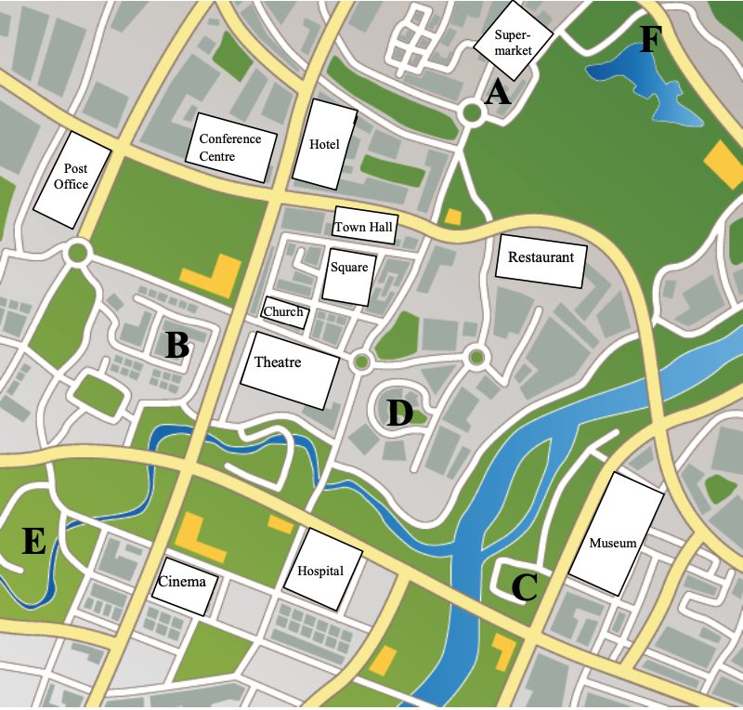
- from the sport centre (E) to the lake (F)?

AST3 Unit 7

Unit 7 - Car manufacturing

- Look at the picture of the car below and match the main parts of the car to the picture.

- bumper
- bonnet (BrE) / hood (AmE)
- headlights
- windscreen (BrE) / windshield (AmE)
- number plate (BrE) / license plate (AmE)
- steering wheel
- indicator
- wing mirror (BrE) / side mirror (AmE)
- tyres (BrE) / tires (AmE)
- boot

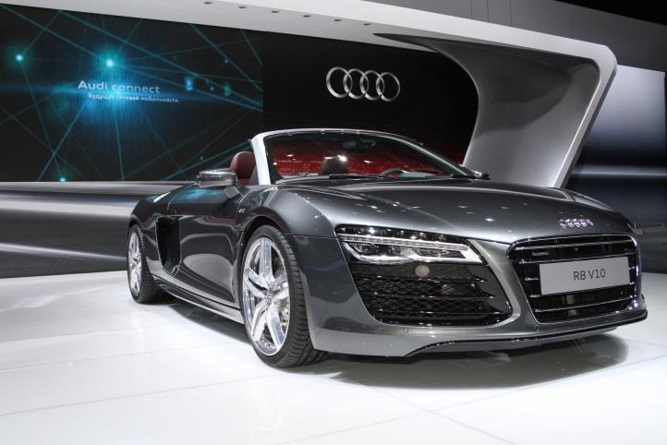

- Match the car parts with their definitions.

- engine
- rear-view mirror
- exhaust pipe
- suspension
- transmission

- clutch
- accelerator
- brake
- petrol tank (BrE) / gas tank (AmE)
- windscreen wiper (BrE) / / windshield wiper (AmE)

- the part at the back of a car through which waste gas escapes from the engine
- a mirror inside a car that allows a driver to see what is happening behind their car
- the pedal in a car that is used to change gears
- a machine that uses the energy from fuel to produce movement
- one of two long metal and rubber parts that move against a windscreen to remove rain
- the pedal in a car that makes it go faster
- a container that holds fuel
- equipment attached to the wheels; it reduces the uncomfortable effects of driving over bumpy roads
- the machinery that brings the power produced by the engine to the wheels of a car
- the pedal that makes a car go slower or stop
definitions: dictionary.cambridge.org

AST3 Unit 8

Unit 8 - Function

- Look at the pictures of various things. Match the pictures with the verbs below describing the main function of these objects.

hit / boil / cool down / listen / measure / loosen or tighten / heat / call / open / wash / navigate

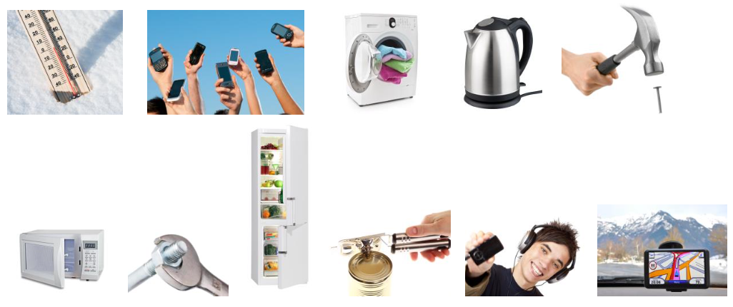

- Choose six objects from the pictures above and write down six sentences that describe their function.

Example: A kettle is used for boiling water.

- ______________ is used to __________________________________________________.
- ______________ is used for _________________________________________________.
- ______________ acts as a(n) _________________________________________________.
- ______________ is used to __________________________________________________.
- ______________ is used for _________________________________________________.
- ______________ acts as a(n) _________________________________________________.
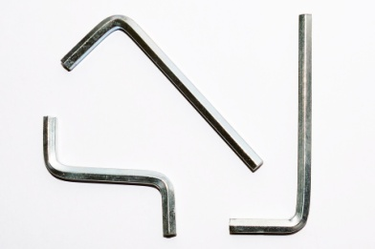
- Do you know the names of tools in English? Match the words with the pictures.
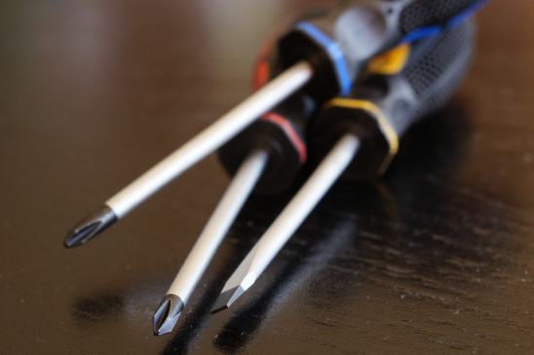
- Allen key = hex key
- Philips screwdriver
- flat blade screwdriver
- spanner = wrench
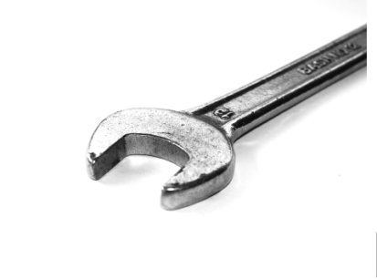
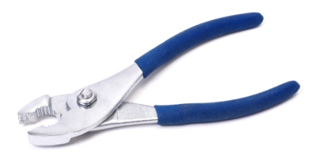
- pliers

source: pixabay.com

- Work in pairs. What are the tools from ex.3 used for?
________________________________________________________________________________________________________________________________________________________________________________________________________________________________________________________________________________________________________________________________

- Complete the sentences with the following words.

machine / appliance / tool / device

- An _____________ is a piece of equipment for a specific task, typically for domestic use.
- A _____________ is used for a particular function, usually held in one hand.
- A _____________ usually has several parts and uses power to do work.
- A _____________ is an object or a machine that fulfills a particular purpose.

- Rewrite the sentences, using the word(s) in brackets.

- A lathe removes unwanted material from a workpiece by rotating it against a cutting tool. (used)
- A grinding machine uses an abrasive wheel which finishes workpieces. (acts as)
- A drilling machine produces holes in hard substances. (for)

AST3 Unit 9

Unit 9 - Giving instructions

- Match the following words with the pictures.

- flat tyre (BrE) / flat tire (AmE)
- spare wheel
- wheel nuts
- hubcaps
- jack
- lug wrench
1.
2.
3.
4.
5.
6.
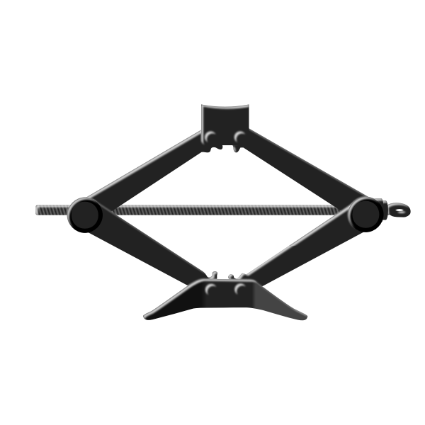 | 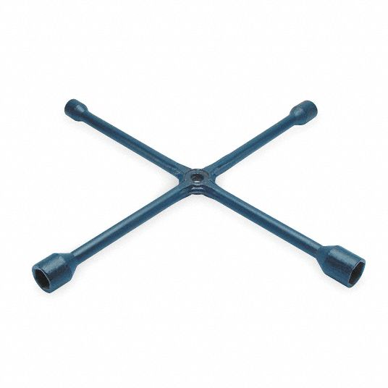 | 
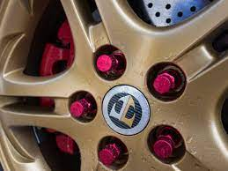 | 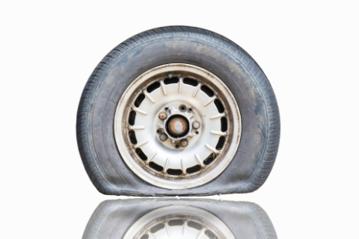 | 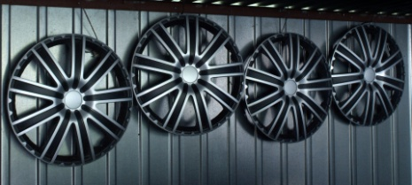

sources: pixabay.com, freesvg.org and commons.wikimedia.org

AST3 Unit 10

Unit 10- Shapes

- Listen to the instructions and draw what the man in the recording tells you. (AST3, 5.1)

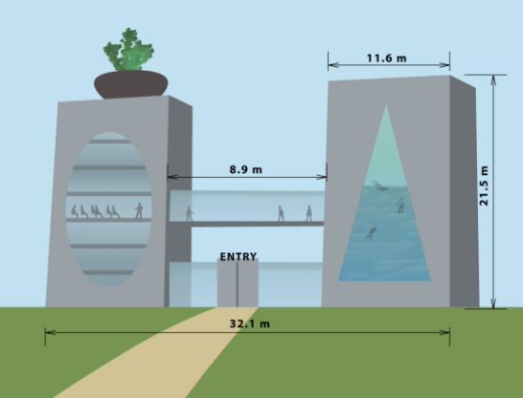
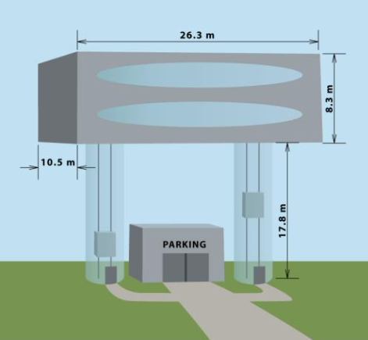
- Look at the pictures of the two buildings. With your partner, describe their shapes and design.

_____________________________________ _____________________________________
_____________________________________ _____________________________________
_____________________________________ _____________________________________
_____________________________________ _____________________________________
_____________________________________ _____________________________________
_____________________________________ _____________________________________
_____________________________________ _____________________________________
_____________________________________ _____________________________________
_____________________________________ _____________________________________
_____________________________________ _____________________________________
_____________________________________ _____________________________________

- Draw a simple design and then describe it to your partner. He or she needs to draw it according to your description without looking at it.

AST3 Unit 11

Unit 11 - Comparison

- Make questions or answers.

- _______________________________________________________________?
The desk is 200 cm wide.
- How old is the building?
__________________________________________________________________.
- _______________________________________________________________?
The Baltic Sea is 500 m deep.
- What’s the weight of the parcel?
__________________________________________________________________.
- _______________________________________________________________?
Mount Sniezka is 1602 m high.

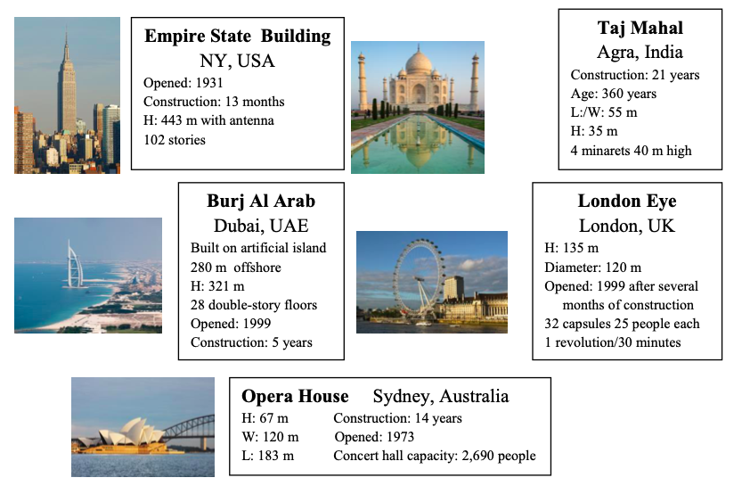
- Look at the information about some famous buildings. Answer the questions according to the facts given and your own knowledge.
370 years

- Which structure is the oldest? What’s its age?
- What is the height of the second tallest building?
- What is the width of the Opera House in Sydney?
- Which building is the lowest?
- Which structure is as wide as the London Eye?
- How long is the Taj Mahal?

- Write these numbers in words and complete the rules with the words below.
- 86.504 _______________________________________________________________________
- 86,504 _______________________________________________________________________

point (.) comma (,) point (.)

We use a _________________ to divide the whole number and decimal numbers. We use a __________________to divide thousands and hundreds in the number. After a _________________, we read the numbers as separate numbers.

- Read the description of SuperJet. Fill in the gaps with a suitable form of the adjective in brackets.

SuperJet 888 – (a) ____________________ (expensive) jet in the world!
Launched at the Jet Fair last month, SuperJet 888 is (b) ____________________ (modern) jet in the world. It is much (c) ____________________ (fast) and also (d) __________________ (big) than Airbus 380. On the other hand, it is much (e) ____________________ (heavy) than any other aircraft. SuperJet is equipped with (f) ____________________ (intelligent) autopilot that engineers have invented so far. This means that a crew is not needed in the cockpit. SuperJet is also (g) ____________________ (safe) and (h) ____________________ (comfortable) than other planes. The seats are much (i) ____________________ (wide) and (j) ____________________ (soft) than we are used to. The best thing, however, are the flight attendants. They are all robots covered with (k) ____________________ (sensitive) skin layer you can imagine. They really look like people! Their voices are, of course, (l) ____________________ (unnatural) than that of humans, but they can speak all the languages in the world, so it is (m) ____________________ (easy) for people who don’t speak languages other than their own. The only problem with SuperJet is the price of the ticket. It is much (n) _______________________ (expensive) than you might think. The basic cost is 5,000 Euros per ticket, but that is only for (o) ____________________ (short) flights. The cost of (p) _______________ (long) flights, to Japan or Sydney, for example, may climb to 11,000 Euros! But it is definitely worth it.

AST3 Unit 12

Unit 12 - Definitions + vocabulary revision

- Look at the examples below and do the exercises (a-g):

Examples:
- The email that I received yesterday was really urgent.
- The operator who is in charge is waiting in the office.
- We could use the drill which I borrowed from my neighbour.
- The lecturer that teaches ”Mechanics of Materials” is very strict.

- Focus on the underlined relative clause (first example). Can you find and underline defining relative clauses in the remaining sentences?
- What words do relative clauses describe? __________________________________________
- Defining relative clauses give information that is unnecessary / necessary to understand the sentence completely.
- Never / Always use commas in these sentences.
- When relative pronouns who, which or that are followed by a verb, the pronoun can / cannot be left out.
- When relative pronouns who, which or that are followed by a noun or pronoun, the relative pronoun can / cannot be left out.
- Use who / which / that for people, who / which / that for things and animals.

- Finish the following definitions with defining relative clauses:

- A fitter is a technician ___________________________________________________________.
- Statics is a subject ______________________________________________________________.
- A jack is a tool ________________________________________________________________.
- A bonnet is a car part ___________________________________________________________.
- "Yours sincerely" is a closing _____________________________________________________.
- A lathe is a machine ____________________________________________________________.

- Make one sentence from two. Use who, that or which:
a) The welder was injured in the accident. He is now in surgery.
_______________________________________________________________________________.
b) Could I leave a message? It would describe all the details.
_______________________________________________________________________________.
c) The bumper needs to be replaced. It got dented.
_______________________________________________________________________________.
d) The client replied to our email and attached the documents. You talked to her two days ago.
_______________________________________________________________________________.

- Write down definitions for the following words. Use defining relative clauses:
a) pliers
_______________________________________________________________________________.
b) sphere
_______________________________________________________________________________.
c) maintenance technician
_______________________________________________________________________________.
d) differential
_______________________________________________________________________________.
e) supervisor
_______________________________________________________________________________.

